**Integration Design Document**

**Template**

April 2022

**Project Goldilocks – ANZ**

Version: v0.1

Status: Draft

**

**Kraft Heinz Project Goldilocks Contact**

|  |  |  |  |  |
| --- | --- | --- | --- | --- |
| **Organization** | **Role** | **Name** | **Email** | **Approved On** |
| IBM | Solution Architect |  |  |  |
| IBM | Integration Lead |  |  |  |
| IBM | Functional Lead |  |  |  |
| KRAFT HEINZC | Business Process Lead |  |  |  |
| KRAFT HEINZC | Program Manager |  |  |  |
| IBM | Program Manager |  |  |  |

**Application Contact**

*[Insert name and title for the person Designing, Building and Integrating the Application.]*

|  |  |  |  |  |
| --- | --- | --- | --- | --- |
| **Organization** | **Role** | **Name** | **Email** | **Approved On** |
|  |  |  |  |  |
|  |  |  |  |  |
|  |  |  |  |  |
|  |  |  |  |  |
|  |  |  |  |  |
|  |  |  |  |  |

**Amendment history**

|  |  |  |  |
| --- | --- | --- | --- |
| **Revision Number** | **Revision Date** | **Summary of Changes** | **Revised By** |
| V0.1 |  | Initial Draft |  |
|  |  |  |  |
|  |  |  |  |
|  |  |  |  |
|  |  |  |  |
|  |  |  |  |

**Definitions**

|  |  |
| --- | --- |
| **Term** | **Definition** |
| S/4 HANA | Project Goldilocks Delivered ERP System |
| RTM | Requirement Traceability Matrix |
| BPH | Business Process Hierarchy |
| KDD | Key Design Decision |
|  |  |
|  |  |

Table of Contents

Table of Contents 3

1 Introduction 5

1.1 Document Purpose 5

1.2 Background 5

1.3 Business Objectives and Project Scope 5

1.4 Solution Principles 5

1.5 Document Structure 6

2 Integration Design 6

2.1 Application Overview 6

2.2 Overall Solution Approach for Project Goldilocks 6

2.2.1 End state 6

2.2.2 Interim state (If Applicable) 7

2.3 Key Design Decisions 7

2.4 Assumptions & Dependencies 7

2.5 Application Components 8

2.6 Enablers 8

2.7 General Constraints 8

2.8 Development Methods 8

2.9 Limitations and Exclusions 9

3 Technical Architecture 9

3.1 Technical Architecture Overview 9

3.2 Environment Management 9

3.3 Capacity Considerations 9

3.4 Disaster Recovery 10

3.5 Backup, Monitoring, Alerting and Logging 10

3.6 Patching and Upgrades 10

3.7 Security Architecture 10

3.7.1 Security Architecture Overview 10

3.7.2 Identity and Access Management 10

3.7.3 Application Security 10

3.7.4 Data Security 10

4 User Experience 10

4.1 User Experience Changes 10

4.2 Training Needs 10

5 Delivery Plan on a Page & Delivery Milestones 11

5.1 Project Goldilocks Plan on a Page 11

5.2 Application Milestones integrated with Project Goldilocks 11

5.3 Status Reporting Requirements 11

6 Integration Build Effort & Cost Estimates for Oracle Demantra 12

7 Ongoing Maintenance 12

8 Appendix 12

# Introduction

## Document Purpose

The Integration design document will describe the Data Migration for ANZ Goldilocks Project between S4 Hana system and Snowflake Database using SAP Data Intelligence tool. The requirements for an effective data integration are evaluated and described in the Integration Design Document. It outlines the intended system behavior and functionality.

## Background

The purpose of this project is to host the data in Snowflake beyond the retention period for further analysis. Data generated in S/4 system will be ingest to Snowflake tables using SAP DI. Existing BPCS/JDE system will be replaced by SAP S4 HANA.Analytics that would need data from S/4 and external applications will be performed in Snowflake and visualized in Tableau.

## Solution Principles

# Analytics on the data available in S/4 will be performed in S/4 itself.

# Data generated in S/4 will be hosted in Snowflake beyond the retention period for further analysis.

# Analytics that would need data from S/4 and external applications will be performed in Snowflake and visualized in Tableau.

Solution:

1. Adopt NOT Adapt to IMPACT​
2. Strong business justification for gaps identified e.g., legal and / or statutory requirements​
3. Standard API/Interface Method​
4. Training and Change begin in Design​
5. Leverage existing master data standards, workflows, and governance procedures​
6. Plant rollout should be load and go​
7. Design and set foundation for Central Finance and Global Chart of Accounts​

Execution:

1. The solution will go through a build, test (INT1, INT2 & INT3), Deploy phase following the methodology on section 2.8
2. Program weekly reporting cadence during execution will be followed. Section 8 in the document provides the reporting template.
3. Application team will support the Project Goldilocks timelines as per the following high level summary schedule:

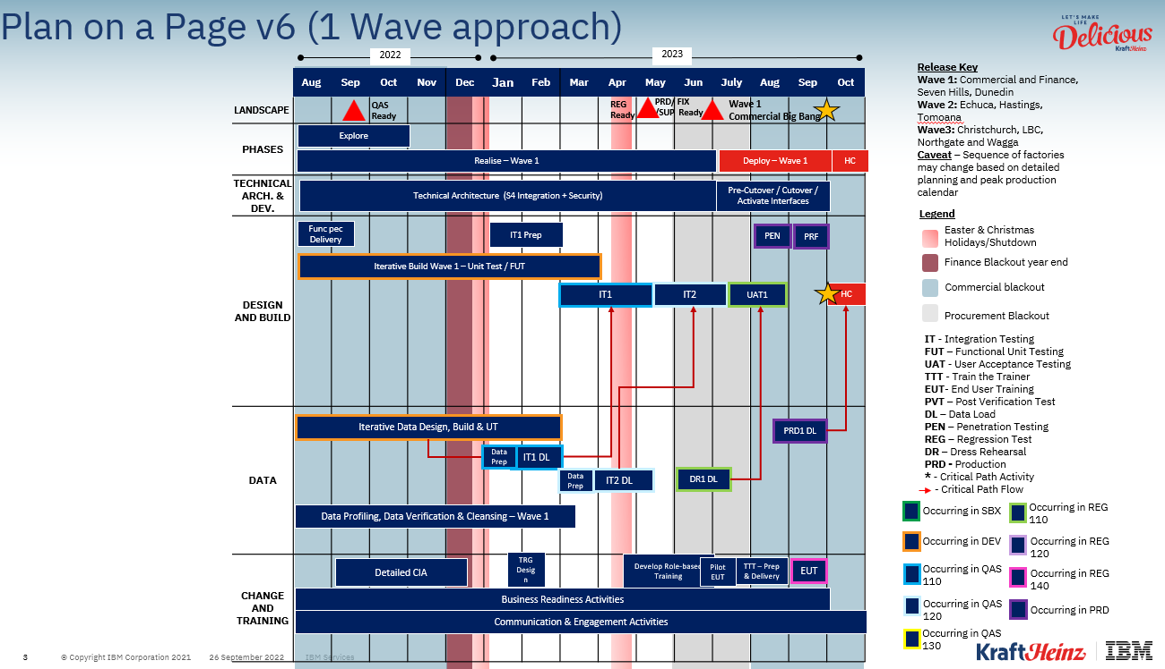

Implementation:

1. Application teams will be available to support the deployment of the solution, including the hyper care.

## 1.4 Document Structure

The sections below include:

* Integration Design,
* Technical Architecture,
* User Experience,
* Design Limitations & Exclusions,
* Delivery Plan & Milestones
* Effort & Cost Estimate
* Ongoing Maintenance

# Integration Design

## Application Overview

In the Goldilocks ANZ architecture, we have SAP S/4 Hana application which holds the transactional data. Data is stored in underlying Hana database tables. There are multiple standard CDS views which are built on top of Tables are present in S/4 Hana Application. These CDS views are accessible and used to extract the data using SAP DI Tool.

## Overall Solution Approach for Project Goldilocks

### End state

* Existing BPCS/JDE system will be replaced by SAP S4 HANA
* Standard Operational and Analytical reports will be part of S4 Embedded analytics
* Flexibility to build custom reports can be developed in Fiori by consumers
* Data moves from S4 HANA to Snowflake via DI (Data Intelligence)
* Analytical reporting will be part of Tableau

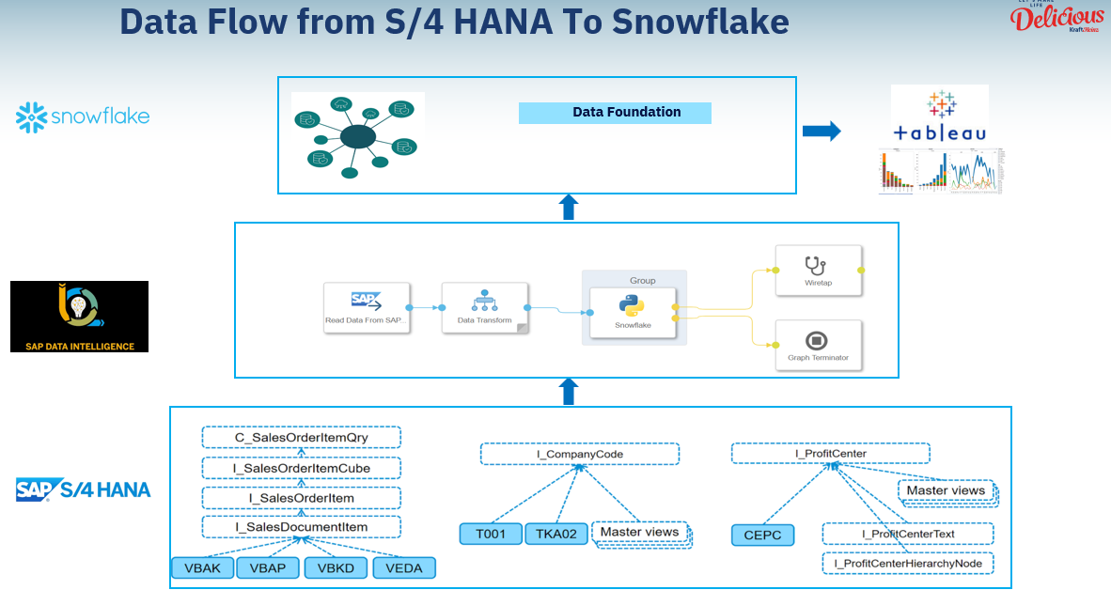

### Interim state (If Applicable)

*[If integration is required to support the Wave 2 & 3 plants, insert the architecture if it differs from the end state.)]*

## Key Design Decisions

|  |  |  |  |  |  |  |
| --- | --- | --- | --- | --- | --- | --- |
| **ID** | **Title** | **Description** | **Functional Area** | **Key considerations** | **Decision** | **Reference document** |
|  |  |  |  |  |  |  |
|  |  |  |  |  |  |  |

*[KRAFT HEINZ Integration team will insert the key decisions and change requests relevant to the subject application.)]*

## Assumptions & Dependencies

|  |  |
| --- | --- |
| **ID** | **Assumption** |
| 1 | Data extraction from S/4 System will be through CDS views via ABAP RFC connection using SAP DI tool. |
| 2 | Full and Delta extraction from S/4 system will depend on the CDS views extraction capabilities. If CDS view is delta enabled, then only it will support the delta extraction. |
| 3 | Replication of data from S/4 to snowflake can be done using real time pipelines in SAP DI or on daily scheduling basis. Final approach will be based on the business/IT design discussions. |
| 4 | Minimal or no data transform is required in SAP DI. |

## Application Components

S4 Hana system, SAP Data Intelligence, Snowflake, Tableau

## Enablers

ABAP RFC Connection for Data extraction from DI.

## CDS Views extraction enabled in S4 Hana system.

Snowflake connector Docker file installation for Data loads.

## General Constraints

All mandatory CDS views required for data extraction for ANZ Goldilocks will be based on the Data foundation requirements mentioned in the mapping design document.

SAP DI will support the below load method from S4 Hana:

* Read all the data from the CDS view once (initial load)
* Initial load and then follow up on subsequent changes (replication)
* Follow up on changes only without doing an initial load first (delta load)

The CDS view with dataExtraction annotations must be enabled for replication (including initial load) and replication (delta load) extraction.

## Development Methods

***[****retain this section of the document.]*

Project Goldilocks will follow the IBM Ascend methodology of Discover, Prepare, Explore, Realize and Deploy.

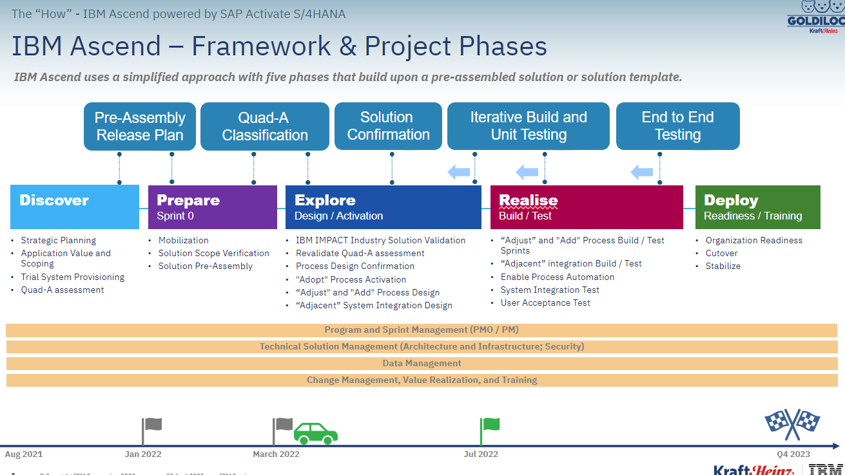

## Limitations and Exclusions

CDC Mechanism is dependent on S4H CDS views and its based-on database trigger. DI is not able to rectify any issues related to CDC , it needs to handled at S4H application and table level.

# Technical Architecture

## Technical Architecture Overview

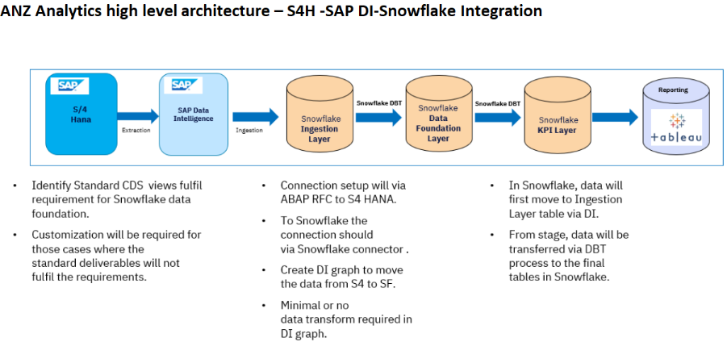

As depicted in the diagram above, Snowflake will receive the data information in the Ingestion Layer from the S4 SAP system through the established integration approach using SAP DI.

Pipelines in SAP DI will be scheduled daily in full or delta mode depends upon the design to extract the raw data from S4 system and load into the ingestion layer of Snowflake.

## Environment Management

ANZ Goldilocks project has Two instances of S4 Hana system as of now.

1. EAD system 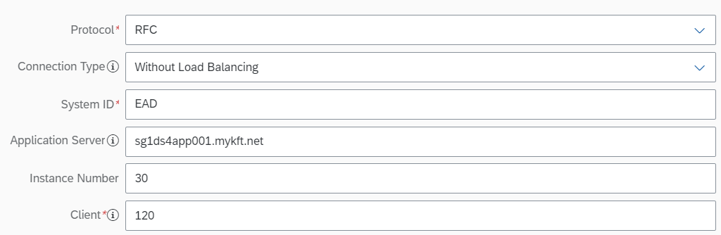
2. EAX system 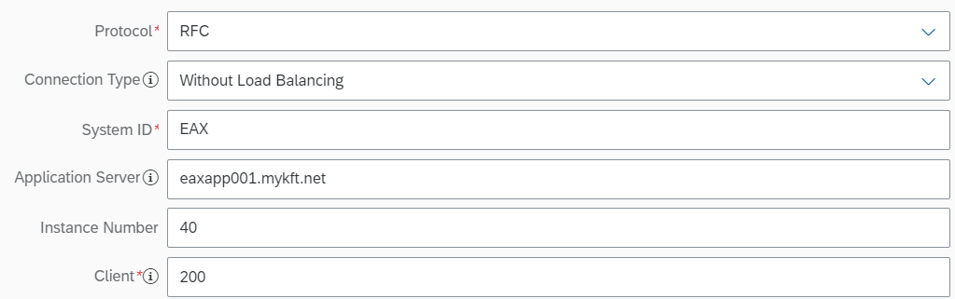

All the build and testing activities would be carried out in above two instances.

For SAP DI, there are two server, Sandbox and Development available for ANZ Goldilocks.

1. Development url : <https://apacdidev.mykft.net/> and Tenant - dadapp001
2. Sandbox url: <https://daxapp001.mykft.net/> and Tenant - daxapp001

Deployment to the production instance will be made post successful testing and receiving a technical signoff from the project business sponsor.

Snowflake Database and Schemas in Ingestion Layer

1. Database Name - DEV_KHC_INGEST
2. Schema Name - SAP_MASTER_DATA, ORDER_MANAGEMENT, INVENTORY_MANAGEMENT,FACILITY,FINANCE,MANUFACTURING

## Capacity Considerations

*Kraftheinz, across Australia will have CDS views daily refresh. As of now in Dev system Data volume is quite low in Full and Delta load. Stated details below:*

The current supported transaction volumes are expected to continue from S/4 HANA.

|  |  |  |  |  |
| --- | --- | --- | --- | --- |
| **S.no** | **CDS Views** | **Full/Delta** | **Frequency​** | **#Records​** |
| 1 | ZB_MDM_PRODUCT_D | Delta | Daily | Avg 10 records |
| 2 | I_PRODUCTGROUPTEXT_2 | Delta | Daily | Avg 5 records |
| 3 | I_ADDITIONALMATERIALGROUP1TEXT | FULL | Daily | Avg 48 records |
| 4 | I_PRODUCTTYPETEXT_2 | FULL | Daily | Avg 1083 records |
| 5 | I_PRODUCTHIERARCHYTEXT | FULL | Daily | Avg 1216 records |
| 6 | I_PRODUCTDESCRIPTION | Delta | Daily | Avg 5 records |
| 7 | ZB_MDM_PLANT_D | FULL | Daily | Avg 41 records |
| 8 | I_CUSTSALESPARTNERFUNC | Delta | Daily | Avg 10 records |
| 9 | I_CUSTOMERBYSALESHIERARCHYNODE | Delta | Daily | Avg 5 records |
| 10 | I_CUSTOMERSALESAREA | Delta | Daily | Avg 8 records |
| 11 | I_REGIONTEXT | FULL | Daily | 75614 |
| 12 | I_PRODUCTCOSTESTIMATE | Delta | Daily | Avg 5 records |
| 13 | I_PRODUCTCOSTESTIMATEITEM | Delta | Daily | Avg 8 records |
| 14 | I_PRODUCTSALESDELIVERY | Delta | Daily | Avg 5 records |
| 15 | I_SALESORGANIZATION | FULL | Daily | Avg 16 records |
| 16 | I_EXCHANGERATERAWDATA | FULL | Daily | 3176 |
| 17 | I_SALESDOCUMENTTYPETEXT | FULL | Daily | 3567 |
| 18 | I_DIVISIONTEXT | FULL | Daily | 45 |
| 19 | I_PRODUCTUNITSOFMEASURE | Delta | Daily | Avg 10 records |
| 20 | ZB_MDM_ADDRESS_D | Delta | Daily | Avg 20 records |
| 21 | I_PRODUCTIONVERSION | FULL | Daily | 26 |
| 22 | I_CLFNOBJECTCHARCVALUEBASIC | Delta | Daily | Avg 5 records |
| 23 | I_CLFNINTERNALIDOBJECTMAPPING | Delta | Daily | Avg 2 records |
| 24 | I_PRODUCTINSPTYPESETTING | Delta | Daily | Avg 2 records |
| 25 | I_CUSTOMERCOMPANY | Delta | Daily | Avg 24 records |
| 26 | I_COMPANYCODE | Delta | Daily | Avg 5 records |
| 27 | I_SALESDISTRICTTEXT | FULL | Daily | 576 |
| 28 | I_ADDITIONALMATERIALGROUP4TEXT | FULL | Daily | 146 |
| 29 | I_PRODUCTUNITOFMEASUREEAN | Delta | Daily | Avg 2 records |
| 30 | I_MATERIALPRICINGGROUPTEXT | FULL | Daily | 182 |
| 31 | I_COSTINGTYPETEXT | FULL | Daily | 450 |
| 32 | C_SALESDOCUMENTITEMDEX_1 | Delta | Daily | Avg 20 records |
| 33 | C_SALESDOCUMENTSCHEDLINEDEX_1 | Delta | Daily | Avg 24 records |
| 34 | I_DELIVERYDOCUMENTITEM | Delta | Daily | Avg 10 records |
| 35 | I_DELIVERYDOCUMENT | Delta | Daily | Avg 24 records |
| 36 | I_CUSTOMER | Delta | Daily | Avg 5 records |
| 37 | I_COUNTRYTEXT | FULL | Daily | 3795 |
| 38 | I_ADDITIONALMATERIALGROUP3TEXT | FULL | Daily | 44 |
| 39 | I_COSTCOMPONENTTEXT | FULL | Daily | 664 |
| 40 | I_ADDITIONALMATERIALGROUP5TEXT | FULL | Daily | 50 |
| 41 | I_CLFNCHARDESC | FULL | Daily | 3570 |
| 42 | C_SALESDOCITMPRCGELMNTDEX_1 | Delta | Daily | Avg 50 records |
| 43 | I_COSTCOMPONENT | FULL | Daily | 664 |
| 44 | I_COSTCOMPONENTGROUPTEXT | FULL | Daily | 151 |
| 45 | C_BillingDocItemBasicDEX_1 | Delta | Daily | Avg 10 records |
| 46 | C_BILLGDOCITMPRCGELMNTBSCDEX_1 | Delta | Daily | Avg 40 record |
| 47 | I_GLAccountLineItemRawData | Delta | Daily | Avg 90 records |
| 48 | I_GLACCOUNTTEXTRAWDATA | Delta | Daily | Avg 5 records |
| 49 | I_DISTRIBUTIONCHANNELTEXT | FULL | Daily | Avg 90 records |
| 50 | I_SALESORGANIZATIONTEXT | FULL | Daily | 225 |
| 51 | C_PurchaseRequisitionItemDEX | Delta | Daily | Avg 5 records |
| 52 | C_PurOrdScheduleLineDEX | Delta | Daily | Avg 10 records |
| 53 | C_PurchaseOrderItemDEX | Delta | Daily | Avg 5 records |
| 54 | C_SupplierInvoiceDEX | Delta | Daily | No data in S4H |
| 55 | C_SupplierInvoiceItemDEX | Delta | Daily | No data in S4H |
| 56 | I_GoodsMovementDocumentDEX | Delta | Daily | Avg 10 records |
| 57 | I_SUPPLIER | Delta | Daily | Avg 5 records |
| 58 | I_SUPPLIERCOMPANY | Delta | Daily | Avg 5 records |
| 59 | I_SUPPLIERPURCHASINGORG | Delta | Daily | Avg 5 records |
| 60 | I_WAREHOUSE | FULL | Daily | 22 |
| 61 | I_WAREHOUSETEXT | FULL | Daily | 176 |
| 62 | I_STORAGELOCATION | FULL | Daily | 540 |
| 63 | C_SalesDocItmPrcgElmntDEX_1 | Delta | Daily | Avg 90 records |
| 64 | I_MATERIALVALUATION | Delta | Daily | Avg 5 records |
| 65 | I_PURCHASINGDOCUMENTHISTORYBSC | Delta | Daily | Avg 5 records |
| 66 | I_MATERIALDOCUMENTRECORD | Delta | Daily | Avg 5 records |
| 67 | C_PurOrdAccountAssignmentDEX | Delta | Daily | Avg 5 records |
| 68 | I_WorkCenter | FULL | Daily | Avg 56 records |
| 69 | I_WorkCenterCostCenter | FULL | Daily | Avg 86 records |
| 70 | I_WorkCenterText | FULL | Daily | Avg 52 records |
| 71 | I_ManufacturingOrder | Delta | Daily | Avg 5 records |
| 72 | I_ManufacturingOrderItem | Delta | Daily | Avg 5 records |
| 73 | I_ManufacturingOrderComponent | Delta | Daily | Avg 10 records |
| 74 | I_ManufacturingOrderOperation | Delta | Daily | Avg 10 records |
| 75 | I_PAYMENTTERMSTEXT | FULL | Daily | 363 |
| 76 | I_GLACCOUNT | FULL | Daily | 47269 |
| 77 | I_FUNCTIONALAREATEXT | Delta | Daily | 555 |
| 78 | I_COSTCENTERTEXT | Delta | Daily | Avg 10 records |
| 79 | I_JournalEntry | Delta | Daily | Avg 10 records |
| 80 | ZB_MDM_LOCATIONWAREHOUSE_D | FULL | Daily | 42 |
| 81 | ZB_MDM_ACCTDOCSTAT_T | FULL | Daily | 240 |
| 82 | I_ACCOUNTINGDOCUMENTTYPETEXT | Full | Daily | 1051 |
| 83 | I_PRODUCTPLANTBASIC | Delta | Daily | Avg 10 records |
| 84 | I_VALUATIONAREA | FULL | Daily | 41 |
| 85 | I_ProductStorageLocationBasic | Delta | Daily | Avg 5 records |
| 86 | ZB_MDM_BATCHSTOCKS_D | Delta | Daily | Avg 5 records |
| 87 | ZB_MDM_BATCHCROSSPLANT_D | Delta | Daily | Avg 5 records |
| 88 | ZB_MDM_BATCHPLANT_D | Delta | Daily | Avg 5 records |
| 89 | C_PURCHASINGSOURCEITEMDEX | Delta | Daily | Avg 2 records |
| 90 | I_BusinessPartner | Delta | Daily | Avg 10 records |
| 91 | ZB_MDM_BPRELATION_D | Delta | Daily | 1 record |
| 92 | ZB_MDM_ProdStorageLocation_F | Delta | Daily | Avg 5 records |
| 93 | I_SALESDOCUMENTITEMCATEGORYT | FULL | Daily | 7456 |
| 94 | I_PURCHASINGDOCUMENTORIGINTEXT | FULL | Daily | 375 |
| 95 | ZB_PTP_PURDOCSUPPLIERCONFIRM_F | Delta | Daily | Avg 10 records |
| 96 | ZB_OTC_SALESDOCUMENTPARTNERS_F | Delta | Daily |  |
| 97 | C_SDDocMultiLevelProcFlowDEX | Delta | Daily |  |
| 98 | ZB_MDM_CLFNCHARVALUE_T | FULL | Daily |  |
| 99 | ZB_MDM_CLFNCHARVALUE_D | FULL | Daily |  |
| 100 | C_PurchasingInfoRecordDEX | Delta | Daily |  |
| 101 | I_ConditionTypeText | FULL | Daily |  |
| 102 | ZB_PTP_PLANORDER_F | Delta | Daily |  |
| 103 | ZB_PTP_PRICINGELEMENTS_F | Delta | Daily |  |
| 104 | ZB_TM_FREIGHTITEM_F | Delta | Daily | Avg 5 records |
| 105 | ZB_TM_FREIGHTHDR_F | Delta | Daily | Avg 5 records |
| 106 | ZB_TM_FREIGHTSTOP_F | Delta | Daily | Avg 5 records |
| 107 | ZB_TM_FREIGHTEXECUTION_F | Delta | Daily | Avg 5 records |
| 108 | ZB_MDM_PURGINFORECDORGPLANT_D | Delta | Daily |  |
| 109 | ZB_MDM_MATERIALINFORECD_D | Delta | Daily |  |
| 110 | ZB_MDM_CONDITIONS1D_D | Delta | Daily |  |
| 111 | I_SALESDOCUMENTRJCNREASONTEXT | FULL | Daily |  |
| 112 | ZB_TM_FREIGHTDOCREF_F | Delta | Daily | Avg 5 records |
| 113 | ZB_TM_FREIGHTCHARGES_F | Delta | Daily | Avg 5 records |
| 114 | ZB_TM_FREIGHTCHARGESITEM_F | Delta | Daily | Avg 5 records |
| 115 | ZB_TM_FREIGHTSETTLEMENTROOT_F | Delta | Daily | Avg 5 records |
| 116 | ZB_TM_FREIGHTSETTLEMENTITEM_F | Delta | Daily | Avg 5 records |

## Disaster Recovery

The SAP Data Intelligence will cover the necessary steps that will be taken in response to and for the recovery from any disaster affecting the Data loads.

Mechanism is implemented on Error handling of DI Pipelines.

Below configuration defines how the operator handles unexpected exceptions. The available options are:

1. Terminate on error: Unexpected exceptions are logged and the graph is terminated. 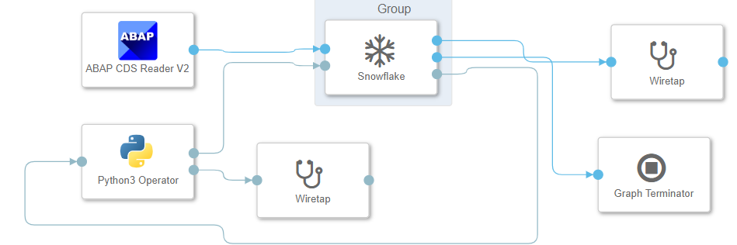
2. Log and ignore: unexpected exceptions are logged and the operator continues to run.

For ANZ Goldilocks as part of design strategy it is feasible to go for Option 1 i.e. Terminate on error in order to avoid Data loss.

As soon as the graph terminated due to any error , it will generate the Error CSV files with timestamp in SAP DI repository which contain the error records( Records that are failed to loaded in Snowflake).

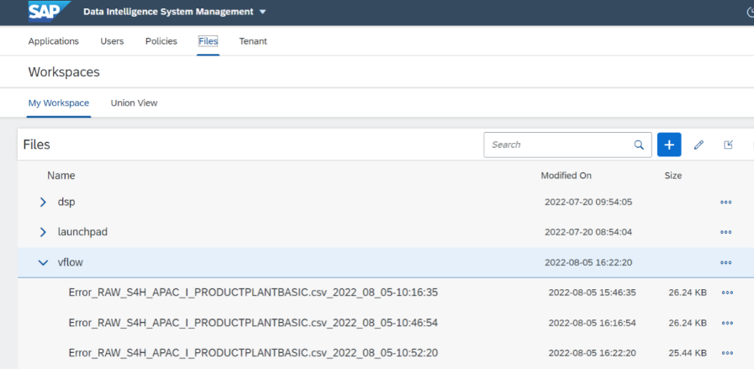

Automatic Graph Recovery

ABAP CDS Reader operators now have a feature called subscription, which enables you to resume execution of a graph containing any of these operators after it has been stopped - no matter whether it was stopped automatically due to an error or manually by a user.

If you have a graph that includes one of these operators and want to start it for the first time, you choose subscription type New and enter a unique meaningful name for the subscription. The system then automatically creates a technical ID (subscription ID) for this subscription in the ABAP-based source system. (This subscription ID is needed, for example, to follow up on technical issues with a subscription.)

When a graph is stopped (be it manually or due to an error), you can start the data load process again by resuming the graph. To do so, change the subscription type to Existing and choose the subscription ID for the subscription name you entered when starting the graph for the first time. Note that in some cases it is technically not possible to resume the data load process at exactly the point where it stopped, which can result in missing or duplicate records in the target environment.

All graphs, irrespective of having Generation 1 or Generation 2 operators, can be configured to automatically recover from failure. When enabled, the runtime system monitors the graph for failures and maintains a failure counter. As long as the failure counter is lower than the set Maximum Automatic Retries, the runtime system restarts the graph with the same runtime configuration. If the graph fails within Retry Threshold Time, the error counter is reset.

If the number of retrials reaches the Maximum Automatic Retries, the graph finally fails and the automatic restart stops. However, a finally failed graph can still be restarted manually at any time, even if the trials have been exceeded the Maximum Automatic Retries.

## Backup, Monitoring, Alerting and Logging

For ANZ Goldilocks we have monitoring mechanism available in SAP Data Intelligence application which offers the following capabilities.

1. The Analytics tab in the home page of the monitoring application displays tiles depicting graph execution status.
2. The Status tile displays a pie chart with information on: The number of graph instances executed in the Modeler, The status of graph instances executed. Each sector in the pie chart represents a graph state.
3. The Memory Usage tile displays a line chart for the memory consumption of graphs.
4. The CPU Usage tile displays a line chart for the CPU consumption of graphs.
5. Manage schedules of DI Pipelines.

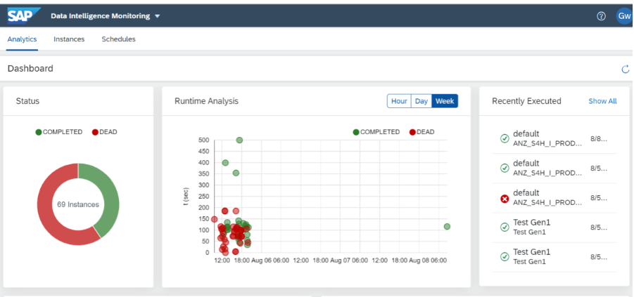

For Alerting, we are setting up email notification mechanism in SAP DI. While data extraction if any of the pipeline got failed due to any error, email will get trigger to ANZ Goldilocks analytics team with actual error description.

## Patching and Upgrades

Any patches and upgrades affecting the users will be communicated by KHC SAP Basis team over email with a scheduled maintenance window.

## Security Architecture

### Application Security Architecture Overview

***[****insert the application security checkpoints. Project Goldilocks security team will provide guidance on the integration components upon entry of firewall.]*

### Identity and Access Management

***[****Input provided by the Project Goldilocks security team.]*

### Data Security

***[****Input provided by the Project Goldilocks security team.]*

# User Experience

## User Experience Changes

***[****insert the impact to the users such as changes to front end, ongoing maintenance, error handling, monitoring etc. Be as descriptive as possible to allow Project Goldilocks OCM teams to manage the change impact.]*

## Training Needs

***[****insert the training needs to support the application.]*

# Delivery Plan on a Page & Delivery Milestones

## Project Goldilocks Plan on a Page

Below is the Plan on a Page with the key critical Milestones listed.



## Application Milestones integrated with Project Goldilocks

|  |  |  |
| --- | --- | --- |
| **SL #+A1:C15** | **Activity** | **TimeLine** |
| **2) SAP System / Data Integration** |  |  |
|  | **Integration Testing** |  |
| 2.1 | SAP DI (Non-Prod) Integration testing with Sandbox and Dev environment of S4H Application is completed. | 30th July |
| 2.2 | SAP DI (Non-Prod) Integration testing with Snowflake Database and schema is completed. | 27th Aug |
| 2.3 | SAP DI Integration with Azure Devops Git repositories for implement deployment of pipelines from one env. to another | 30th Dec |
|  | **Technical Build** |  |
| 2.4.1 | Developing CDS ingestion pipelines in SAP DI | 30th Nov |
| 2.4.2 | Creating tables and view in Ingestion layer of Snowflake | 30th Nov |
| 2.5 | Schedule all the pipelines in Daily execution mode for doing Full and Delta load | 30th Oct |
|  | **Testing and Live Deployment** |  |
| 2.7 | Send test data from DI to Snowflake for DF creation | 30th Sep |
| 2.8 | Testing of CDC mechanism by updating and deleting records in Source system | 30th Oct |
| 2.9 | Test the delta load functionality in DI pipelines and validate the data at snowflake layer. | 30th Sep |
| 2.1 | UAT Testing | 31st Jan |
| 2.11 | Production Deployment | 30th Apr |

# Appendix